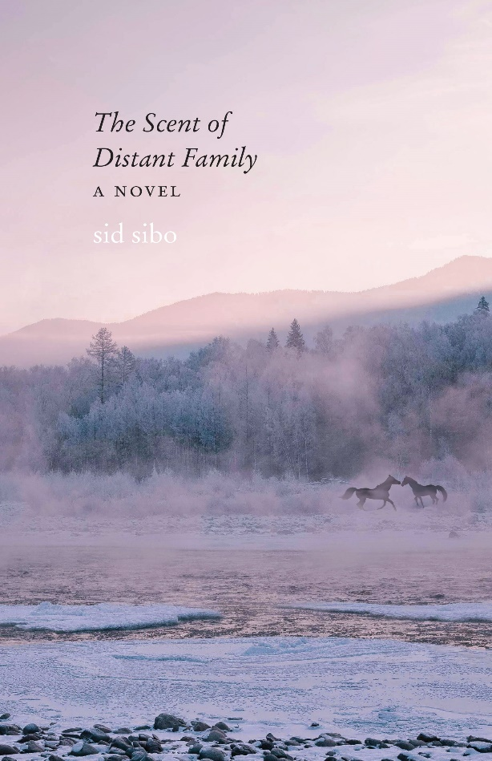 Discussion Ideas

\*\* Though Nik was born and raised in Moon Valley, what are the ways she feels at odds with locals now? If you grew up in a stable location, what ways do you feel like you “belong” there as an adult, or like you don’t? If you live somewhere different now, how much do you feel a part of the community and why?

\*\* Though Finn’s (known) family all lives in this landscape, what are his inspirations for leaving? Can you imagine anything that would lead him to make his home here as an adult?

\*\* Do you think Charlie referring to his wife in the present tense is a sign of decreasing mental function, or would you interpret that in other ways?

\*\* Can you remember going against the grain with a project like Jaye tries to do with her Eco-Ranch ideas? How far were you able to take things? What kinds of barriers did/do you face? Were some internal tensions tormenting you, as well as external challenges? What did you learn from them?

\*\* How did the references to ancient fossils in this landscape play a role in your understanding of the ways we might learn to comprehend family and kinship?

\*\* How did the challenges faced by Zolo and Tess feel in your body? Did you have physical responses to their life-and-death challenges? Did any mental quandaries arise based on the human roles in their struggles? Can you describe story moments of emotional response and/or connection?

\*\* What traits of your favorite characters do you relate to most, or admire? Did anyone show a side of themselves that you relate to but would be less proud about? Is your response—to these characters, or to people around you—increased compassion when you have experienced similar unskillful behaviors or speech, or are you more harshly judgmental because of that?

\*\* The Rocky Mountain West, in literature as in life, is inhabited by strongly traditional people. Do you hold strong opinions about changes in your local landscape or your cultural group or even your workplace? How open to change are the people around you? What changes are you/your friends/family likely to value, and which ones cause stress or turmoil? If you live in or have personal connection to the Rockies, what elements of the status quo that show up in this story would you be open to see change? What changes are you actively working to guide or limit? Are there changes that could cause you to leave your home, wherever that is? How attached to place are you?

\*\* When Nik finally made the decision she wrestled with through the whole story, Jaye was the one who pointed out that it wasn’t her decision to make. How might the difference in age between these two women have made that recognition obvious to Jaye, and much less so for Nik?

{Unconscious bias is a term only more recently a standard part of education; and Nik’s long-term professional competency programmed her to “know the answers” whereas Jaye was still pretty new at her Eco-Ranch venture and wide open to the world of unknowns, her mind more ‘beginner’s mind.’}

What other differences could account for Jaye’s heightened awareness? {Her own “minority” status as lesbian, as a woman “outfitter” on her own…}

\*\* Nik’s new understanding of the value of restraint—not having to be the one who knows what’s right for others—carries over to her decision not to trap Zolo. Can you imagine making that choice for a ‘pet’, or not? What is the value of safety, compared to the value of freedom? {Benjamin Franklin: "Those who would give up essential Liberty, to purchase a little temporary Safety, deserve neither Liberty nor Safety." }

\*\* Someone off-screen intended to own a domestic wolf, before Mariah managed to escape. What reasons might people have for wanting wildlife as ‘pets’? Do any of these reasons seem justifiable to you?

\*\* Hatchery-reared trout are considered wild again just one generation into a life without human support. Wyoming considers elk completely wild though the state feeds them through winter to compensate for all the people living in their former winter habitat. Wild horses are—by Wyoming definitions—not wildlife at all, no matter how many generations they may have lived without any human support. How do you think about these discrepancies across our treatment of different animals? Can you follow some logic behind these differences? Do you believe helicopter roundups and long-term holding pens should be the inevitable fate of bonded mustang families? Do you know of options, for horses, or for people, to live in better harmony with all kinds of wild animals?